Machine | Jenkins job | GitHub repository

EC2-1 — Master | Q1-Job | Q1

EC2-2 — Slave 1 | Q2-Job | Q2

EC2-3 — Slave 2 | Q3-Job | Q3

Step 1: created Jenkins-master instance and ssh into it and install java-21 and git.
And install tomcat server and Jenkins and login into Jenkins master .
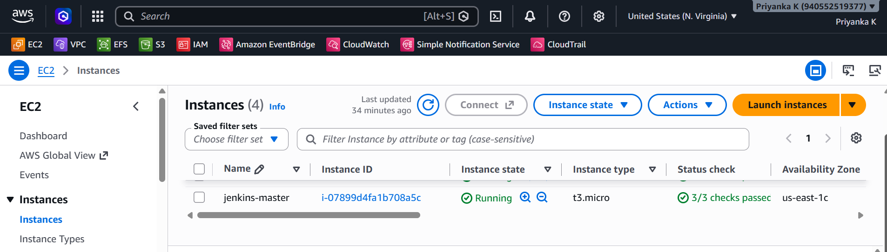

Step 2: created three slaves jenkins-slav1 , Jenkins-slave2 , Jenkins-slave3.
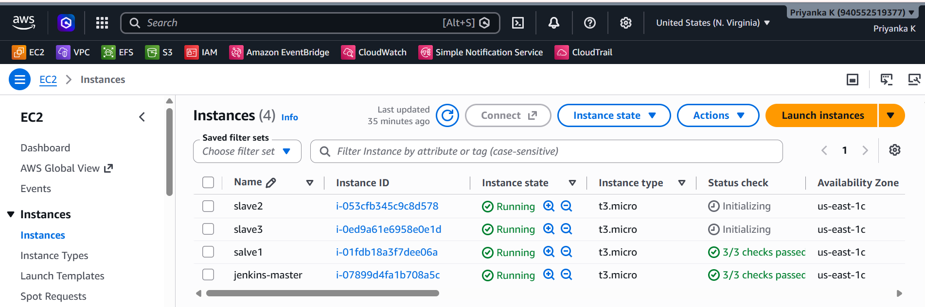

Step 3: ssh into slaves
Install java-21 and git on three slaves. And create separate directory ….cd /mnt---mkdir Jenkins-slave1 and take path of these.

Step 4 : go to manage Jenkins---slect nodes
Created slave1 , slave 2 and slave 3 with same configuration . but with their private-addresses.

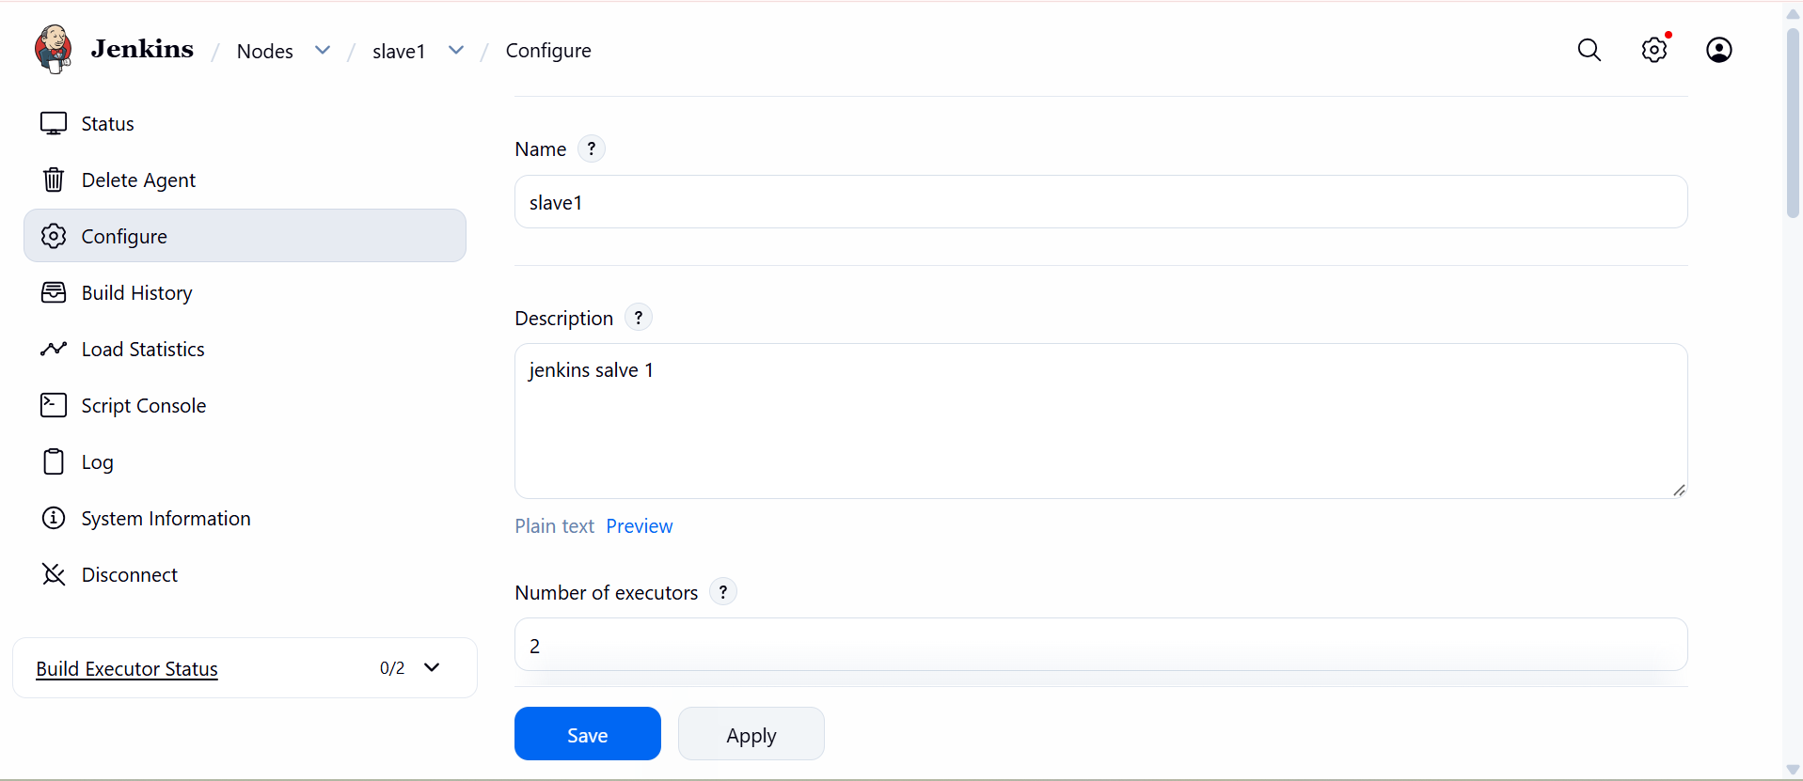

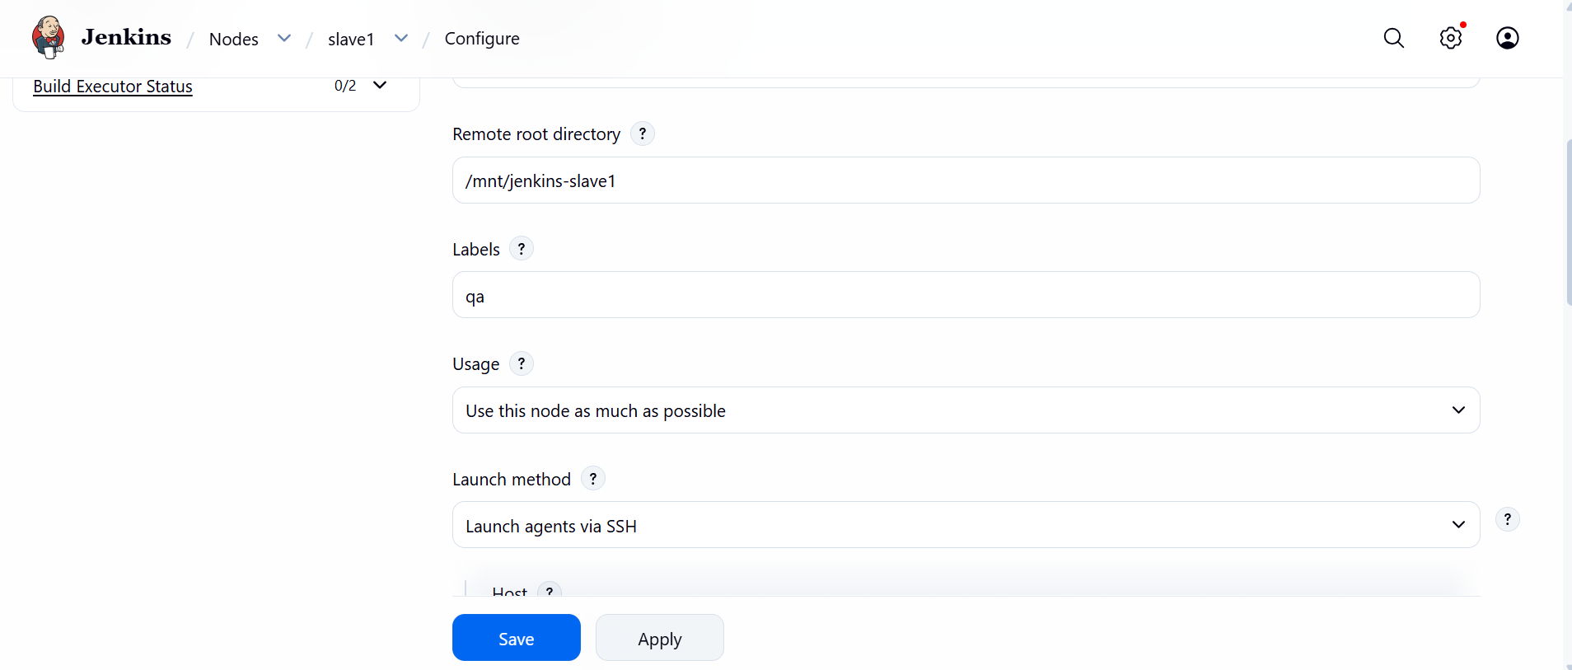
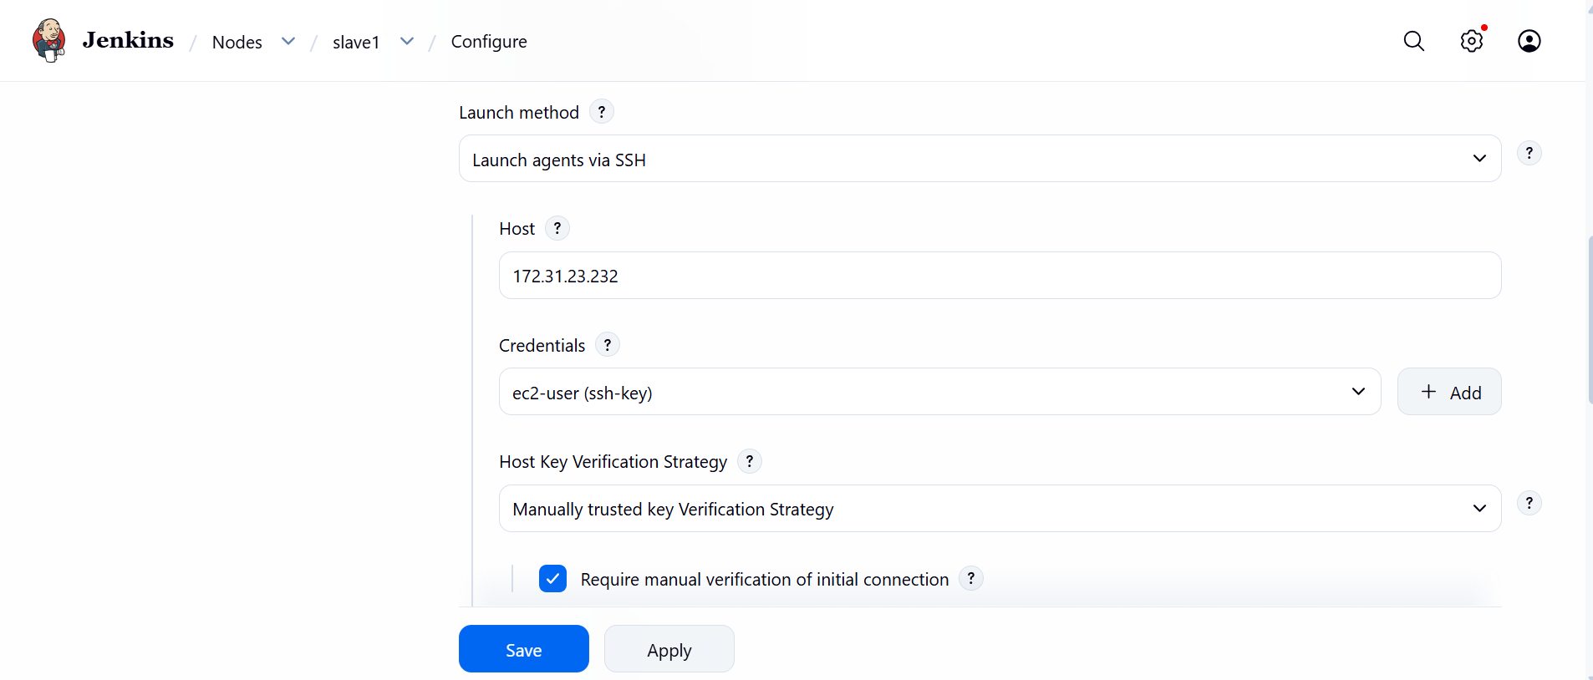

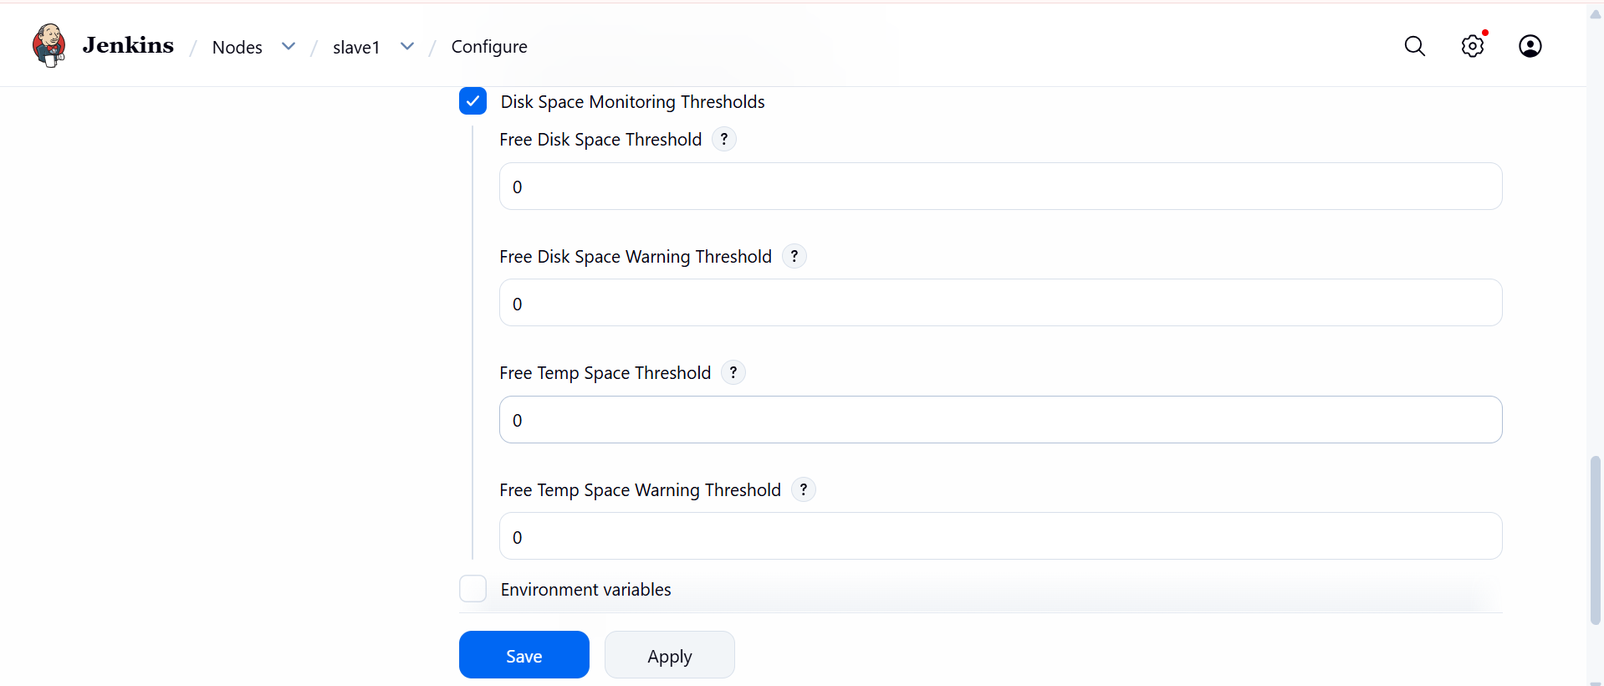

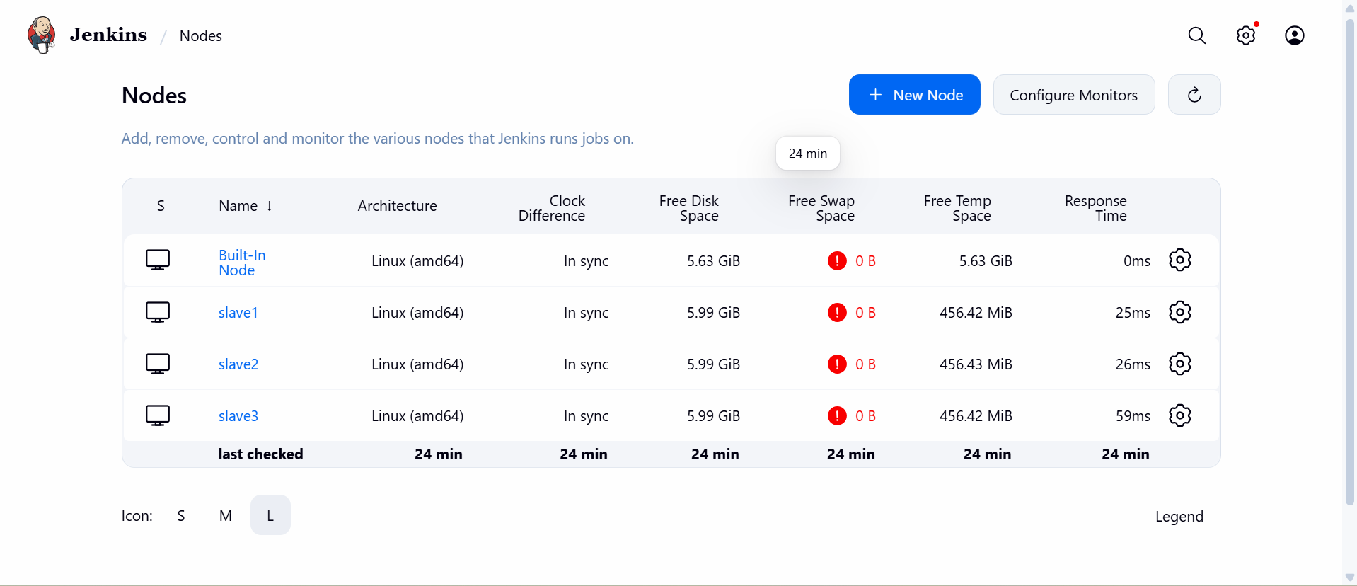
Step 5 : created three jobs with name repo1, repo2, repo3

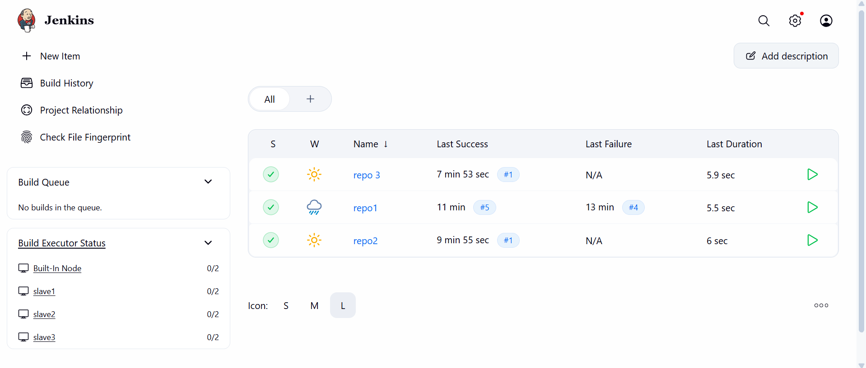

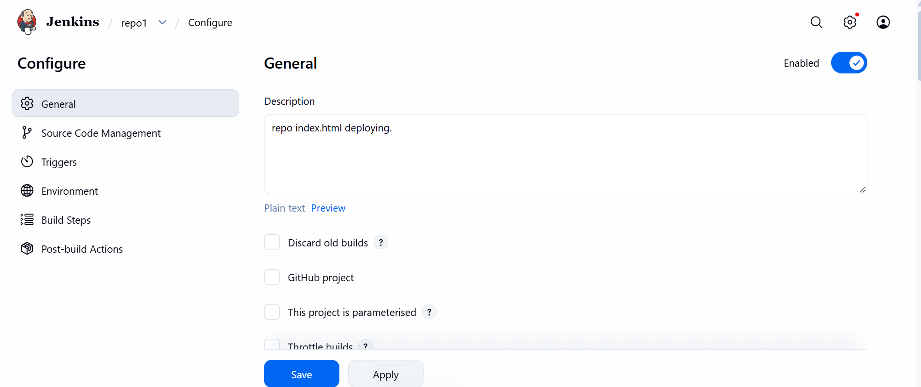

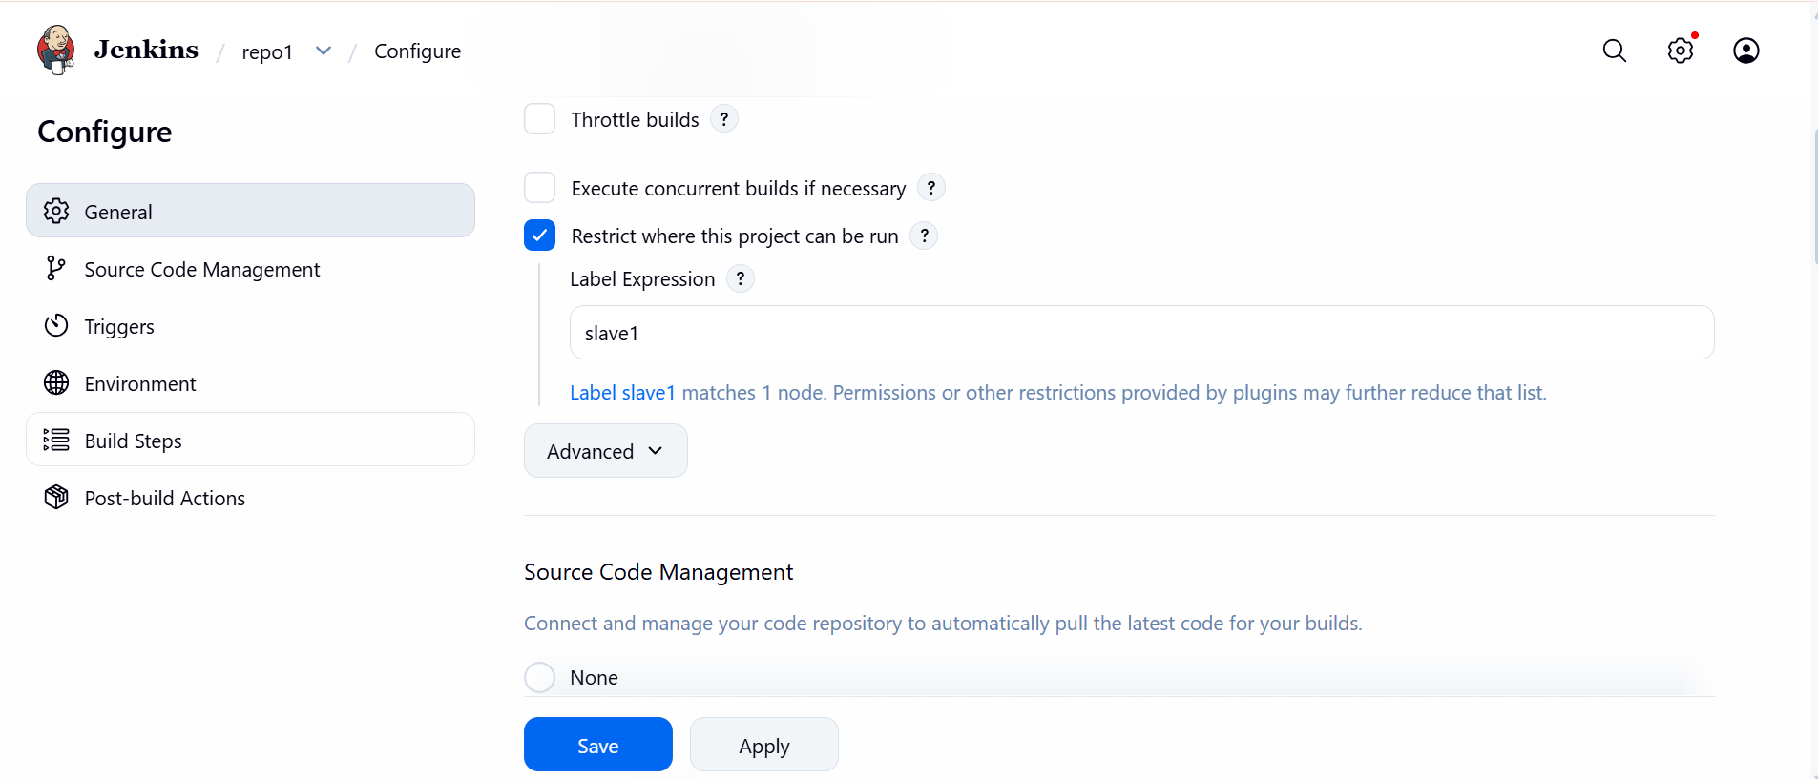
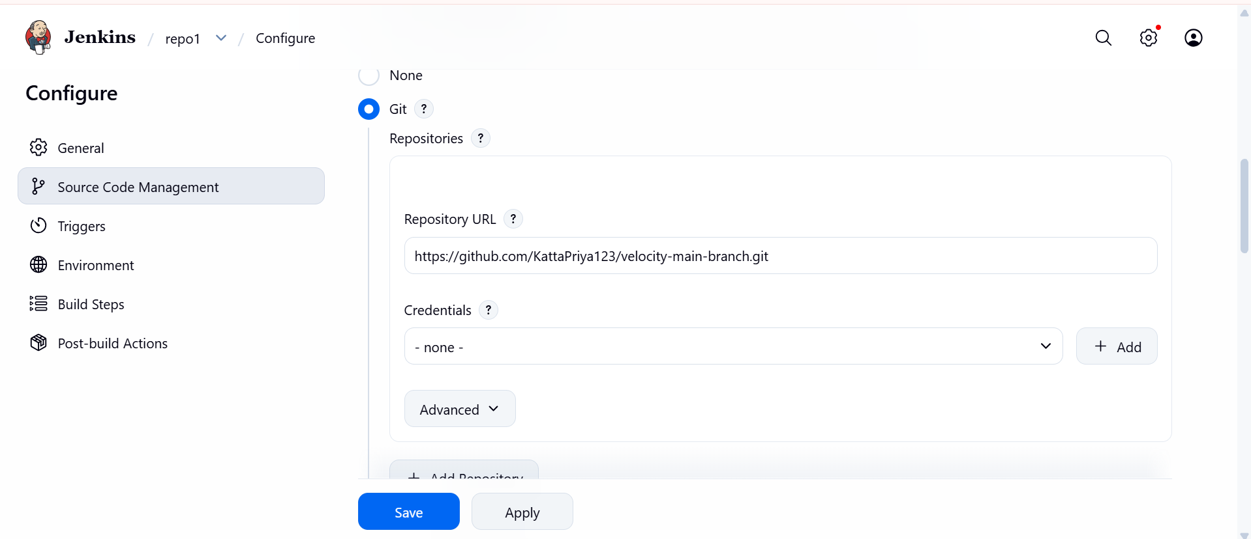

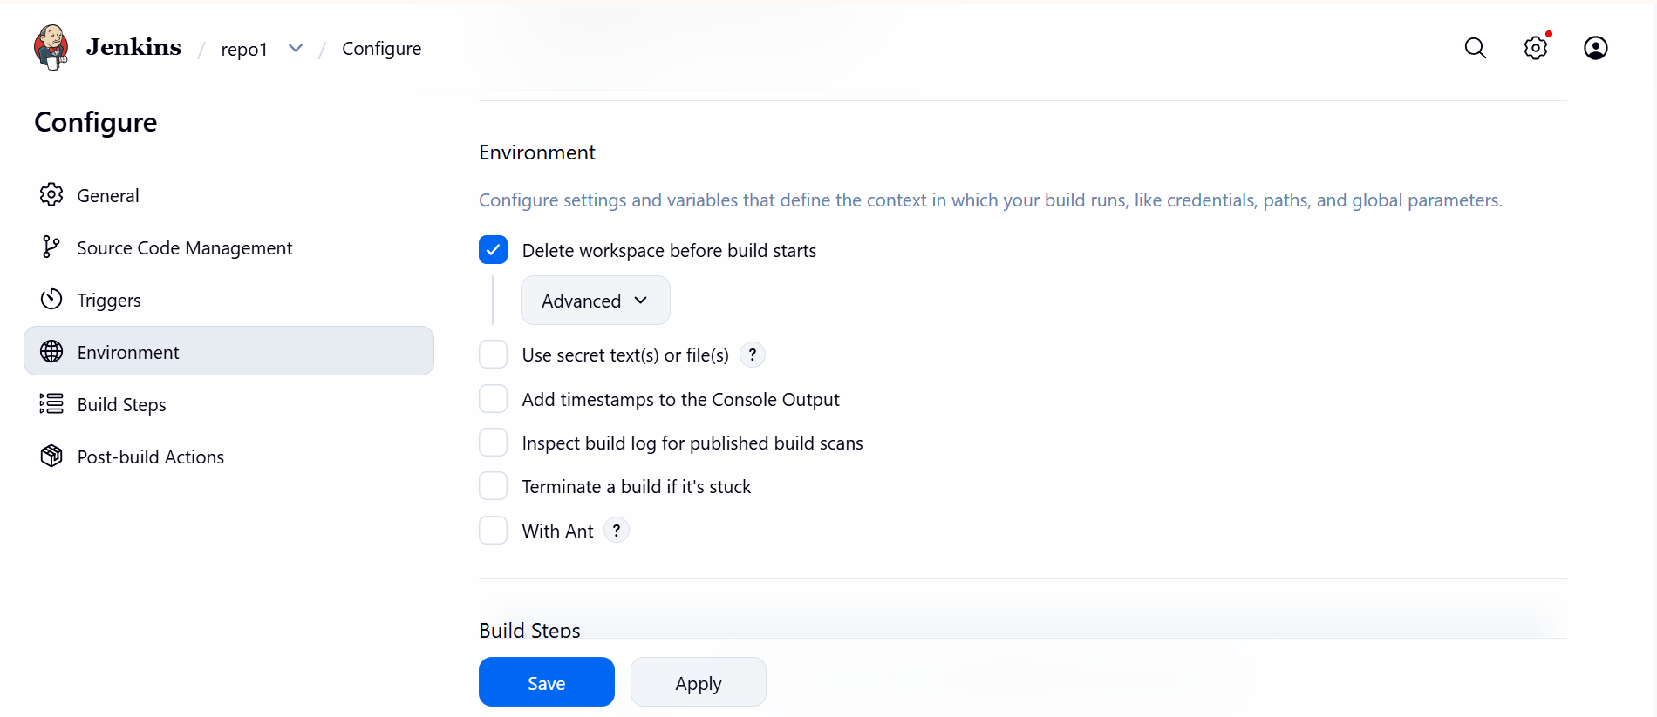
Build the jobs and we can see in console …..job1 build on slave1
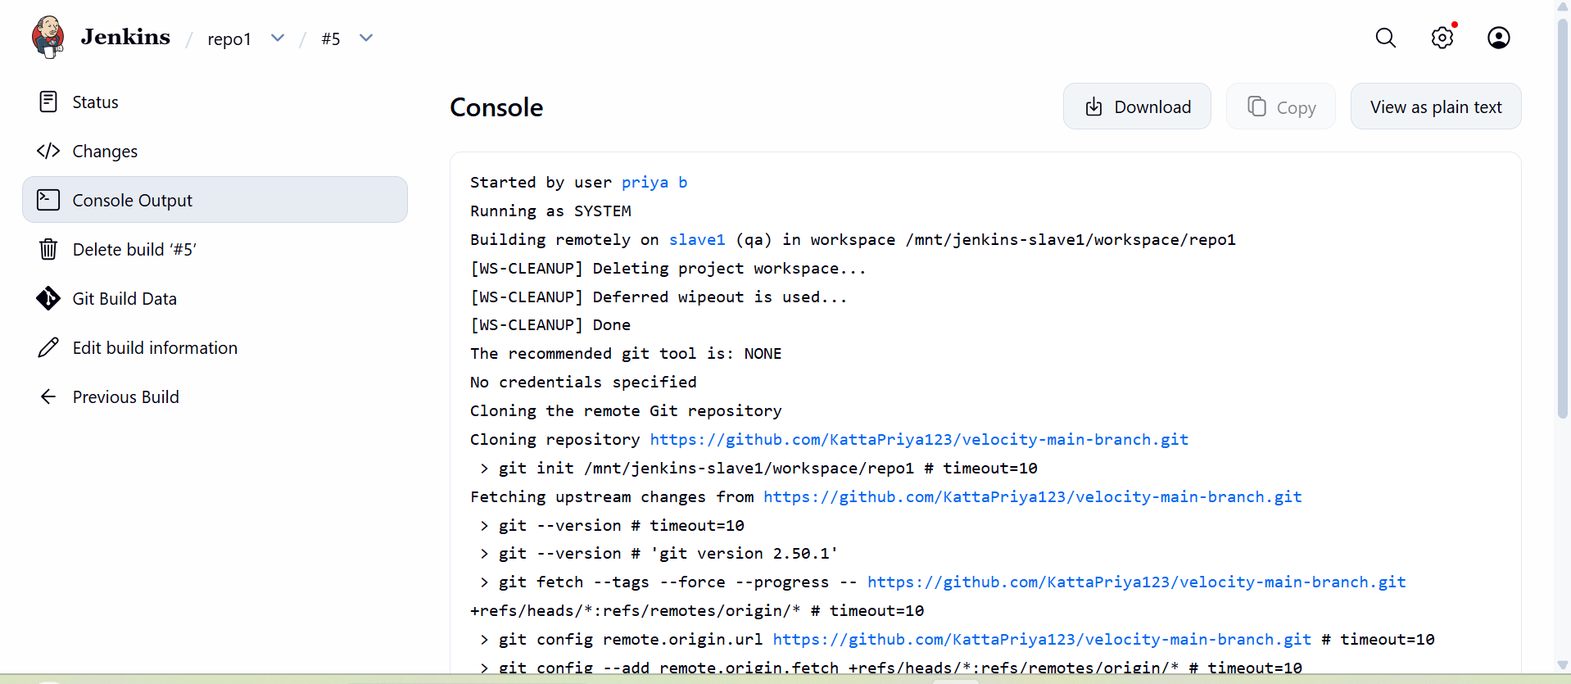
Job2 build on slave2
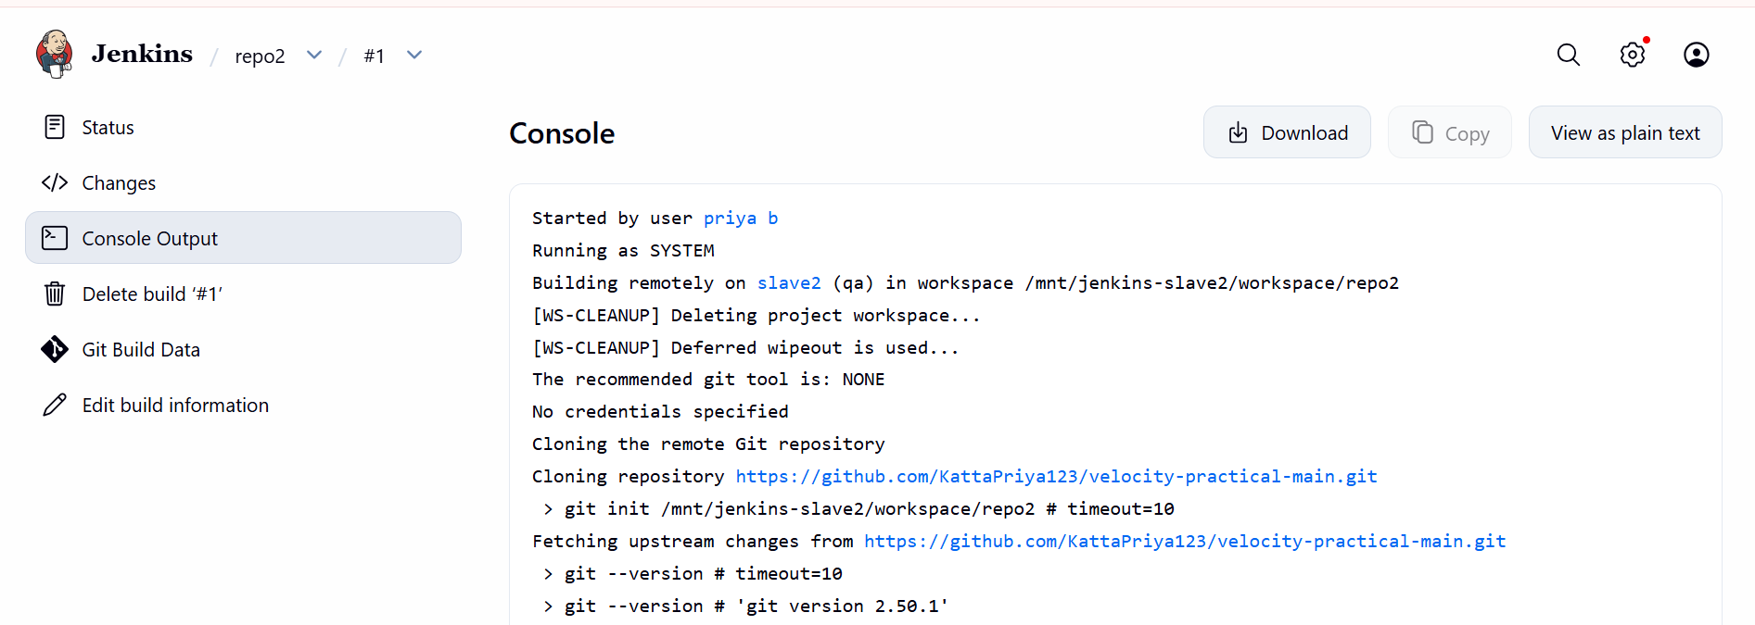

Job3 build on slave3

